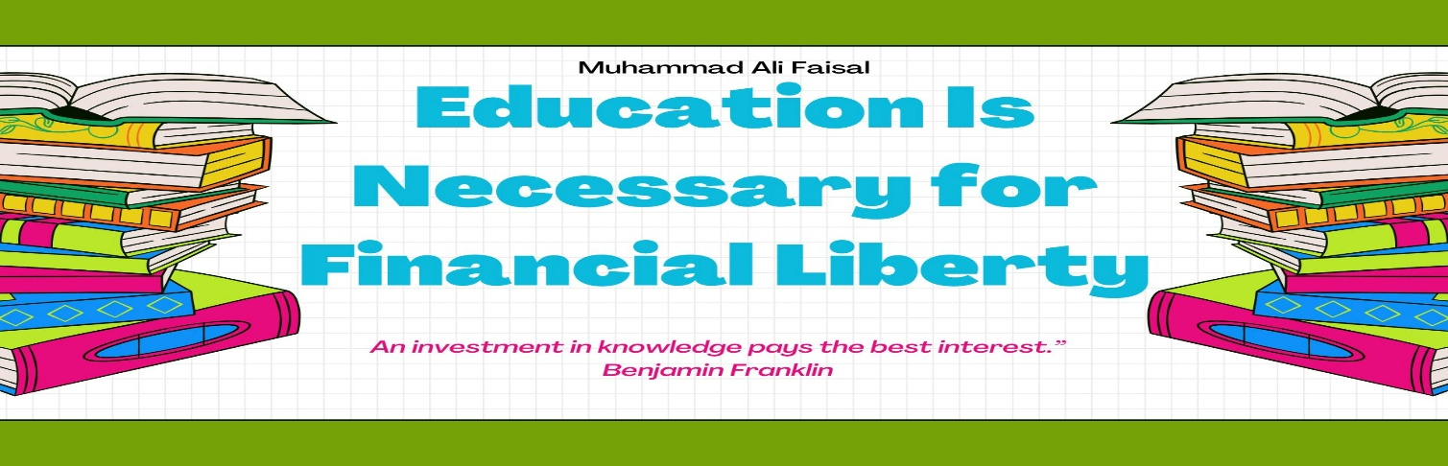

***Education Is Necessary for Financial Liberty***

💰 **Education: The First Step Toward Financial Liberty**

In today’s fast-paced, opportunity-rich world, everyone dreams of financial freedom the ability to live life on your own terms, free from the stress of bills, debts, or financial dependency. But how do we actually achieve this freedom?

The answer begins with one powerful tool: education.

Yes, education is more than just textbooks, degrees, and classrooms. When used wisely, education becomes the foundation for financial liberty, personal empowerment, and a better quality of life.

📘 ***What Is Financial Liberty?***

Before we dive in, let’s define what financial liberty really means.

Financial liberty is having control over your money, rather than your money controlling you. It’s the ability to:

* Pay your bills comfortably
* Save for emergencies and the future
* Invest in opportunities
* Live without constant financial stress
* Choose the work you want to do not the work you’re forced to do

It’s not just about being rich. It’s about having options, freedom, and peace of mind.

🎓 ***How Education Leads to Financial Freedom***

Let’s explore how education plays a central role in unlocking this kind of freedom.

1. 📈 ***Education Builds Earning Power***

The more skilled and knowledgeable you are, the more valuable you become in the job market or business world. Whether it’s a university degree, vocational training, or self-taught digital skills education opens doors to better-paying opportunities.

Even in entrepreneurship, educated individuals are more likely to succeed because they understand how to manage risks, create plans, and innovate.

2. 📊 ***Education Teaches Financial Literacy***

True financial liberty isn’t just about earning money it’s about managing it wisely.

Educational programs that include financial literacy understanding budgeting, saving, investing, taxes, and debt are crucial. Without this knowledge, even people who earn well can find themselves trapped in financial problems.

3. 💼 ***Education Expands Career Options***

A good education gives you the freedom to choose. Instead of being stuck in low-paying or unstable jobs, educated individuals can explore careers in technology, healthcare, engineering, business, education, or even create their own companies.

This choice is a luxury many people never have and it's made possible through learning.

4. 🚀 ***Education Sparks Innovation and Entrepreneurship***

Many of the world’s most successful entrepreneurs from Elon Musk to Oprah Winfrey credit lifelong learning as the reason for their growth. Education helps you think critically, solve problems, and see opportunities where others see obstacles.

This mindset is a key ingredient for building wealth and achieving long-term financial independence.

5. 🧠 ***Education Breaks the Cycle of Poverty***

In communities where poverty is passed down from generation to generation, education is often the breakthrough. An educated individual can uplift their entire family and eventually their whole community by becoming financially independent and inspiring others to do the same.

🔄 ***Real Education Goes Beyond the Classroom***

Keep in mind: financial liberty doesn’t require a college degree alone. It requires the right kind of education practical, relevant, and adaptable. That includes:

Skill-based learning (e.g., coding, marketing, trades)

* Online courses and certifications
* Books, podcasts, and financial blogs
* Learning from mentors and experiences
* It’s not about how long you study it’s about what you learn and how you apply it.

💡 ***Final Thoughts: Invest in Your Mind First***

Money comes and goes, but knowledge stays with you forever. Education gives you the tools to earn, the wisdom to save, and the confidence to grow.

If you’re serious about achieving financial liberty, don’t just chase money chase knowledge. Because the more you learn, the more you earn and the freer you become.

**“An investment in knowledge pays the best interest.”  
*Benjamin Franklin***